A Departmental Quiz was organized by the Department of Computer Applications, SKR GDC, Gudur on 01-09-2022 at 3 PM in Digital Class Room – 3. Three(3) teams – A, B, C with two(2) members each were participated in the quiz and Team-B took 1st position, Team-A took 2nd position. As an encouragement notebooks were gifted to the quiz winners and runners by the lecturers of SKR GDC, Gudur.
List of Participants:
Team-A: 1. E. Keerthana, II B.Com(CA)
2nd Place
2. Sireesha, II B.Com(CA)
Team-B: 1. Sk. Moin, II B.Com(CA)
1st Place
2. Premus Raju, II B.Com(CA)

Team-C: 1. S. Chengaiah, II B.Com(CA)
2. Chandrasekhar, II B.Com(CA)

Photos:
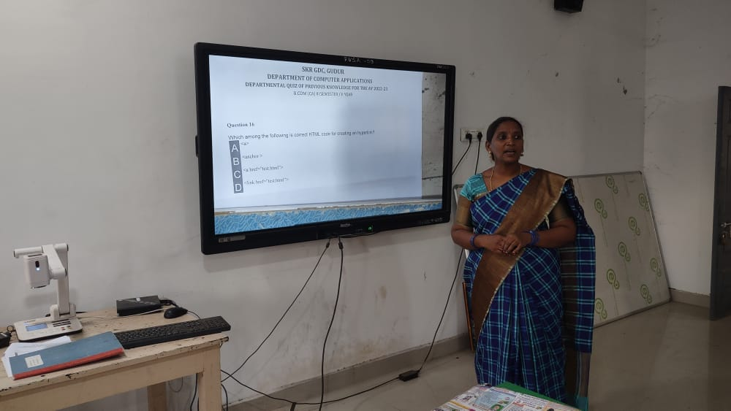 | 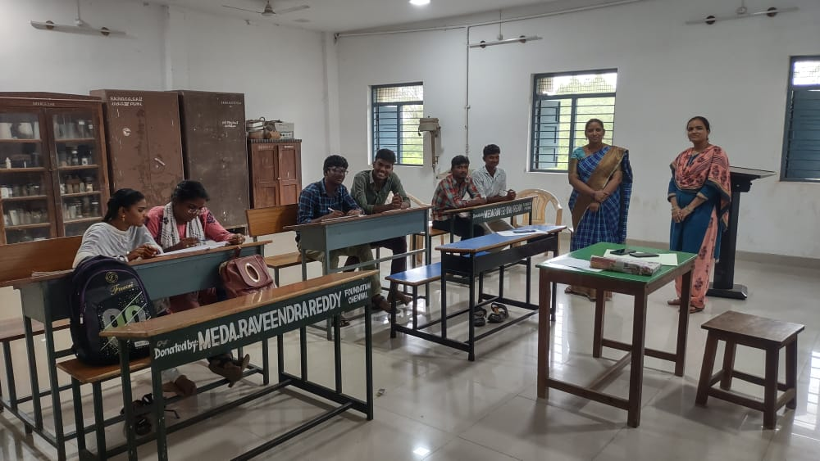
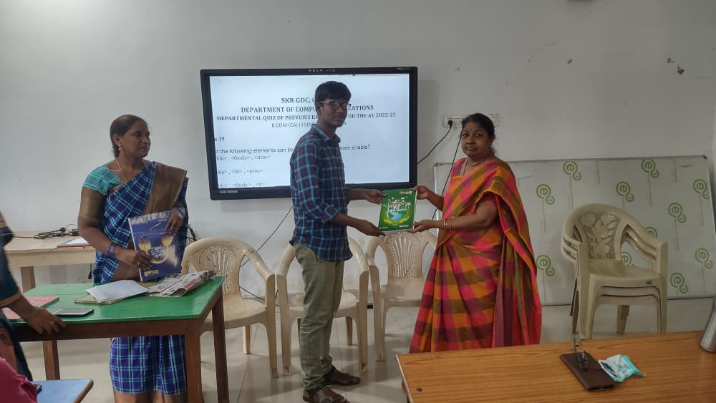 | 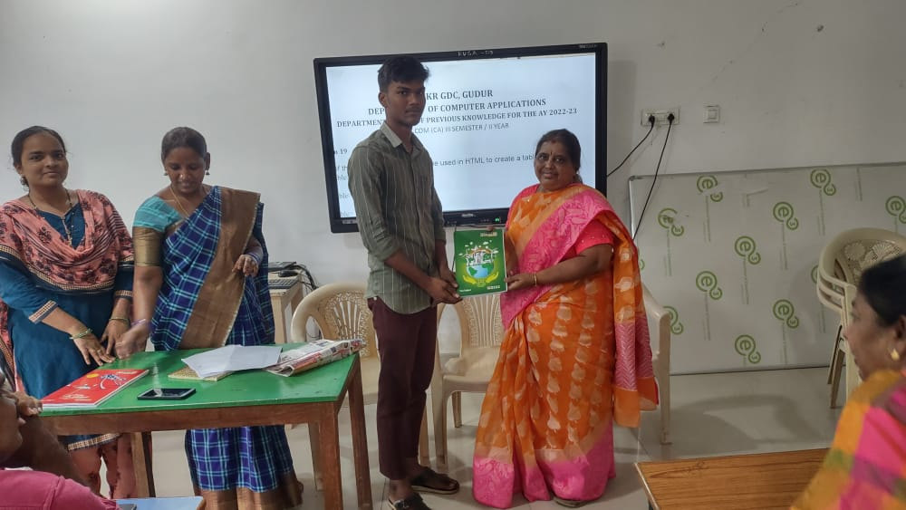
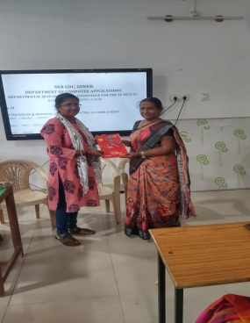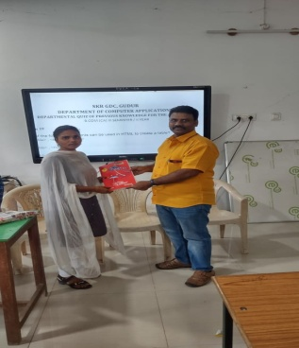 | 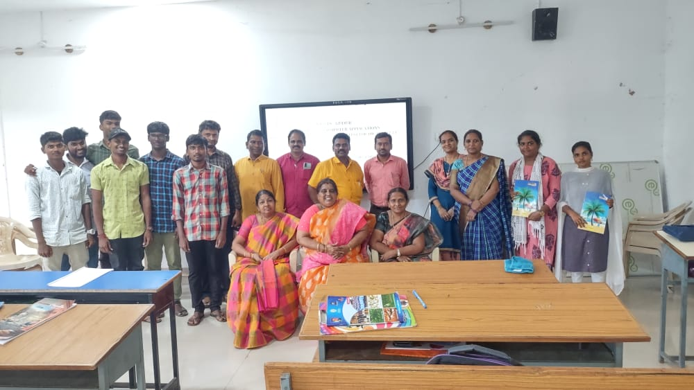
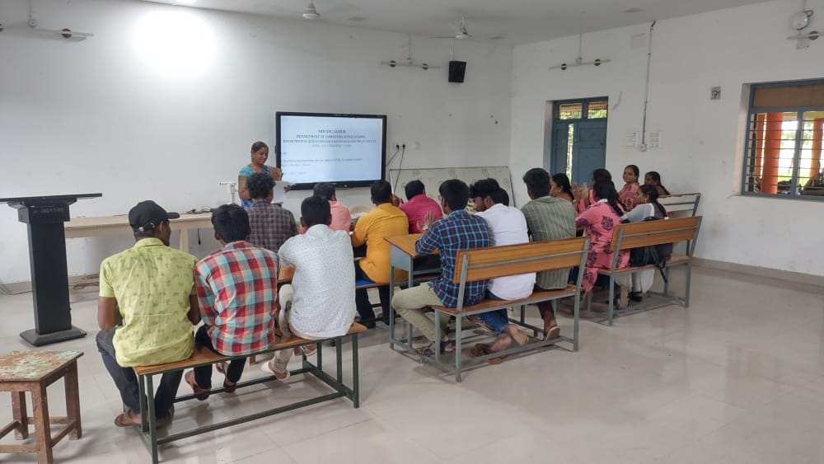 | 